How Do We Do MR Imaging?

Magnetic Field Gradients and Imaging

Table of Contents

*Expected Learning Outcomes* 3

Background Information 3

Classwide Discussion 3

Thought Experiments: How Can We Encode Spatial Information into MR Signal? 4

Guided Inquiry Questions 4

Guided Inquiry Questions 5

A New Form of Imaging 5

Guided Inquiry Questions 6

How Do We Use Gradients to Create Images? 7

Guided Inquiry Questions 8

Modern-Day Imaging 9

Guided Inquiry Questions 10

What Provides Contrast in MRI Images? 11

Proton Density 11

and Weighting 12

Contrast Media 13

Guided Inquiry Questions 13

Reflection Questions 14

Supplemental Readings 15

Cited Sources 15

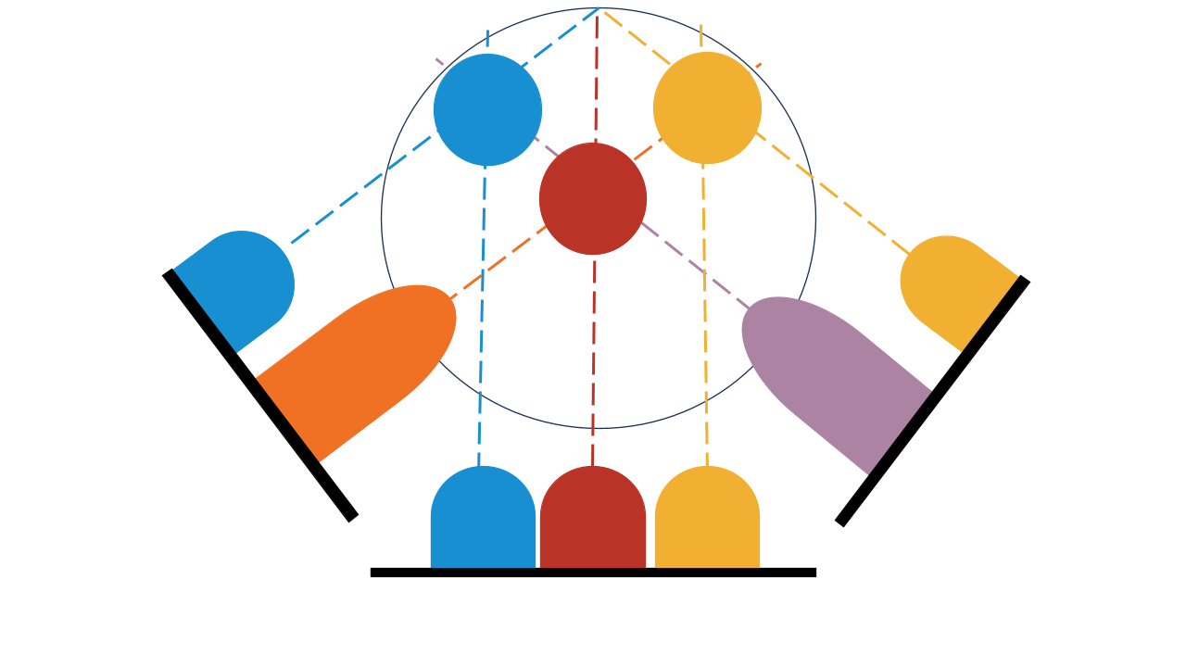

***Example Real-World Application*** Functional magnetic resonance imaging (fMRI) images brain activity by detecting changes associated with blood flow. It is a critical tool for current research mapping the brain and is also being explored for use in clinical work (1).

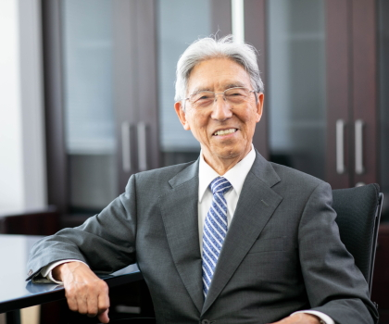***Featured Biophysicist*** Seiji Ogawa is a Japanese biophysicist and neuroscientist who is regarded as the "father of modern functional brain imaging" due to his discovery of the technique behind functional MRI. Dr. Ogawa and his collaborators demonstrated that looking at the changing MRI signal due to varying blood oxygenation levels in different parts of the brain can provide a relative measurement of brain activity in different regions of the brain. Photo courtesy of Dr. Ogawa (2)

## *Expected Learning Outcomes*

*At the end of this module, students should be able to…*

1. *explain the importance of magnetic field gradients for encoding spatial information in MR signal*
2. *identify key differences between MRI and other imaging modalities*
3. *utilize prior knowledge about MR signal to determine different ways to provide contrast to an MR image*

**“Of the many letters received recently what comes through in much of the correspondence is the strong sense of relief at knowing the details of their illness and the hope inspired by the rigorous evaluation of their problem using MRI.”**

— Sir Peter Mansfield, 2003 Nobel Banquet Speech

# Background Information

A lot of different forms of information can be encoded into MR signal, e.g. information about the various nuclei in the sample, the material characteristics that contribute to various relaxation times, and even the molecular structure. Much of modern-day MR research focuses on improving the signal and teasing out even more of this information to fully characterize the sample. In the past few decades, a significant part of the MR research has been dedicated to a very different way of using MR signal - imaging. Nowadays, MR imaging (MRI) is the most well-known application of MR because of its extensive use for clinical research and medical diagnostics.

Here we will explore how we can encode valuable spatial information in our MR signal so that we can create a 3D image of a sample (effectively seeing inside it) without physically cutting up the sample. We will explore how MRI utilizes a whole new imaging paradigm that makes it completely unique from other imaging modalities. Combining imaging with what we have already learned about MR signal will enable us to add various types of contrast to our images, simply by changing a few experimental parameters. This modules provides a introduction to the capabilities of MRI and hints at what all it can offer in the coming decades.

## Classwide Discussion

* What are some different forms of imaging you have seen before?
* How are those images produced?

# Thought Experiments: How Can We Encode Spatial Information into MR Signal?

In order to generate an image, one needs to know about the locations in space of the different sources of the signal. Let’s do the following two thought experiments to consider how this spatial information can potentially be encoded into MR signal.

*Thought Experiment 1: Consider a sample that is split between two different locations in space and placed in a uniform magnetic field, like the one shown below.*

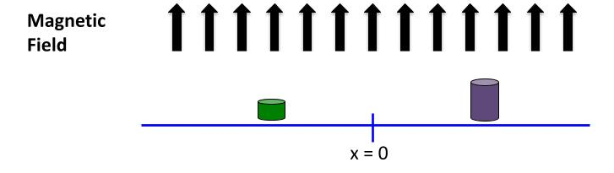Let’s assume the two parts of the sample have identical chemical composition, but the bit of sample on the right has more volume than the bit of sample on the left (designated by the size of the cylinder).

## Guided Inquiry Questions

1. Sketch what you think the MR frequency spectrum of this sample would look like. *Hint: Are the Larmor frequencies different for the different bits of the sample?*
2. Would you be able to determine the spatial distribution of the sample from this frequency spectrum?

**magnetic field gradient** - the strength of the magnetic field varies over space

*Thought Experiment 2: Consider the same sample, but now placed in a known* ***magnetic field gradient*** *- i.e., the magnetic field changes over space (in this case, in a nice linear fashion, as the figure illustrates below).*

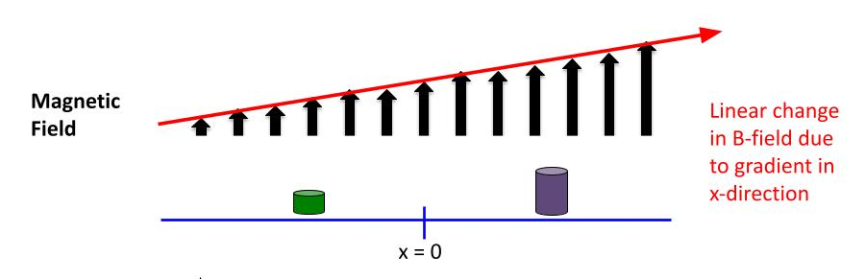

## Guided Inquiry Questions

1. Sketch what you think the MR frequency spectrum of the sample would look like now. *Hint: Are the Larmor frequencies different for the different bits of the sample?*
2. Would you be able to determine the spatial distribution of the sample from this frequency spectrum?

# A New Form of Imaging

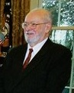Cropped from photo in Public Domain, via Wikimedia Commons (3)

**Paul C. Lauterbur** - American chemist and co-winner of the 2003 Nobel Prize in Physiology or Medicine with Peter Mansfield for the conception and early development of MRI.

“You could write the entire history of science in the last 50 years in terms of papers rejected by *Science* or *Nature*.”  
- Paul Lauterbur

In the summer of 1971, Paul Lauterbur - a chemist who had been developing an interest in the biological applications of NMR - was fascinated by some work down by postdoctoral researcher Leon Saryan at John Hopkins University. Saryan was replicating and expanding upon experiments done by Raymond Damadian that had shown different H NMR relaxation times for implanted tumors versus normal tissues. Lauterbur recognized the potential importance of this information for medical diagnostics in animals if one could localize the results in space rather than averaging them across the entire body.

“That same evening I realized that inhomogeneous magnetic fields labeled signals according to their spatial coordinates, and made a leap of faith to the conclusion that the information could be recovered in the form of pictures.”

— Paul Lauterbur, *Encyclopedia of Nuclear Magnetic Resonance*, Wiley, 1996

Despite initial lack of enthusiasm from various colleagues and institutions about his idea for imaging, Lauterbur did an experiment with a commerical NMR spectrometer at Stony Brook University that demonstrated the potential for creating images by applying additional magnetic field gradients.

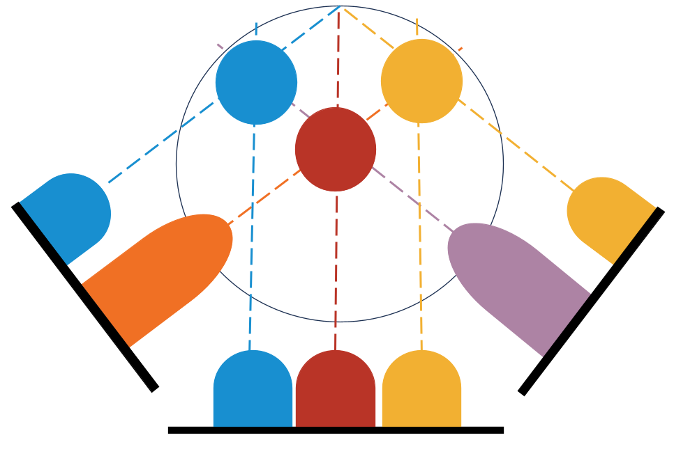Lauterbur wrote up his work in a paper that was initially rejected, but then finally published in *Nature* (4). Along with this proof of concept experiment, this seminal paper explains how this form of imaging is completely different than any others and also foresees many of the amazing medical applications that would soon follow.

Lauterbur creates a 2D image of a sample by combining the projections of the frequency spectra obtained by applying magnetic field gradients in multiple directions. This is illustrated using different colors to show which sample contributes to the different spectral peaks in each projection.

The combination of two different magnetic fields (radio waves for driving NMR transition, and spatially-varying magnetic field gradients) has the unique property of providing a method of imaging that is *not limited by the wavelength of the radiation involved* - a limitation in all optical imaging schemes and also later developed 3D imaging schemes like computed tomography (CT).

## Guided Inquiry Questions

1. Why do gradients need to be applied in multiple different directions in order to build up a multidimensional image?
2. If we want higher resolution images, would you want to increase or decrease the magnetic field gradient (e.g., have more or less variation of magnetic field strength over space)?
3. A higher resolution image means that each pixel in a 2D image (voxel in a 3D image) contains signal from a smaller and smaller area (volume) in space. What might be some limiting factors for the spatial resolution in MRI?

# How Do We Use Gradients to Create Images?

In order to create multidimensional images, one needs to apply magnetic field gradients in multiple directions. Let’s first explore the creation of 2D images through the use of applying gradients in the x- and y-directions with various field strengths. The figure below shows the changes in the magnetic field over a 2D region in space when different x- and z-gradients are applied.

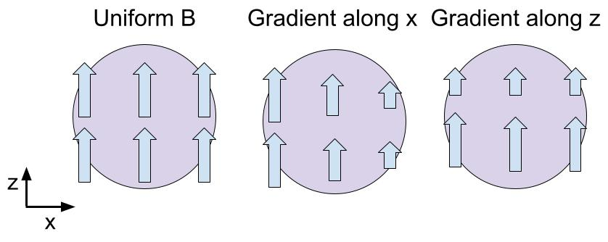

We will get a simple introduction to the use of gradients for localizing MR signal in different regions in space by using the [PhET MRI Simulation](https://phet.colorado.edu/sims/cheerpj/mri/latest/mri.html?simulation=mri). Use the questions below to guide you through your exploration of the simulation.

*The following questions were adapted from one part of the MRI activities created by Cytil Murphy as part of the “Modern Miracle Medical Machines” (5).*

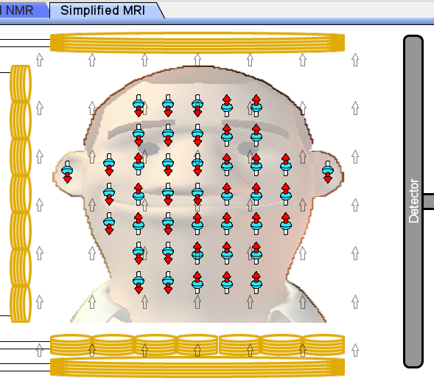Screenshot from the [PhET MRI Simulation](https://phet.colorado.edu/sims/cheerpj/mri/latest/mri.html?simulation=mri).

## Guided Inquiry Questions

1. Once you open the [PhET MRI Simulation](https://phet.colorado.edu/sims/cheerpj/mri/latest/mri.html?simulation=mri), you can click on the tab entitled “Simplified MRI” and should see something similar to the figure in the margin.
2. What are the red, blue, and white arrows representing? What do you think they are represented that way?
3. What do the white block arrows represent? Is the magnetic field being shown homogeneous or inhomogeneous?
4. Check out the “Radiowave Source” control panel at the bottom.

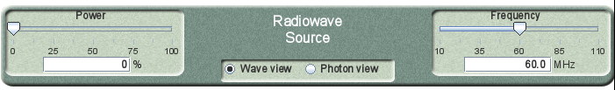

1. 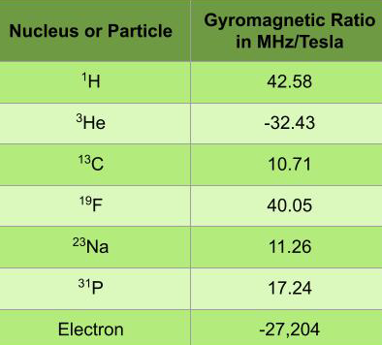What is “Power” controlling?
2. What is “Frequency” controlling?
3. Play around with the controls to determine (roughly) the resonant frequency of the system (without changing any of the magnetic field controls on the right).
4. Describe what happens at this resonant frequency.
5. Using the magnetic field strength given on the right side and the table provided in the margin, what nuclei do you think we are detecting?
6. Check out the control panel on the right side (also shown in the margin on the next page).
7. Describe what happens when you turn up the gradient in the horizontal direction. Where does the magnetic field strength get weaker? Where does it get stronger? Where does it stay the same?
8. Describe what happens when you turn up the gradient in the vertical direction. Where does the magnetic field strength get weaker? Where does it get stronger? Where does it stay the same?
9. 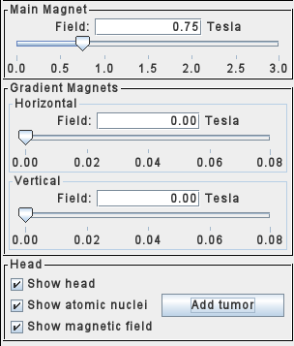Set the frequency of the radio wave source to 42.5 MHz, the main magnet to 1.2 T, and the power of the radiowave source to 100%.
10. What can you adjust so that only the atoms at the top of the head resonate?
11. What can you adjust so that only the atoms in the ear on the left resonate?

*Now let’s go tumor hunting!* A “tumor” in this simulation is an area where there is a high density of atomic nuclei. To make this slightly more realistic, unclick “show atomic nuclei”. You now only have the frequency, magnetic field, and gradient controls to isolate the location of the tumor by looking at the detected signal.

1. Describe a procedure you can use to identify an approximate location for the tumor.
2. Click the “Add tumor” button in the lower right corner and use your procedure to attempt to find the approximate location of the tumor.
3. Which quadrant of the head do you think the tumor is located?
4. After you have made your best attempt to find the tumor, reclick “Show atomic nuclei.” Were you correct about its location?
5. Based on what you have seen in the simulation, how might scientists build up an image using the controls provided?

# Modern-Day Imaging

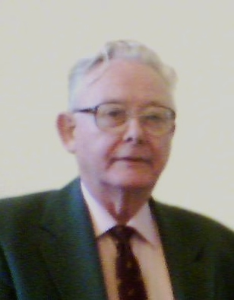Prolineserver, [GFDL 1.2](http://www.gnu.org/licenses/old-licenses/fdl-1.2.html), via Wikimedia Commons (6)

**Sir Peter Mansfield** - British physicist who was the son of a gas fitter and worked while attending night school to get his advanced-level certificate. At 23, he was accepted at Queen Mary's College in London to study physics. There, Mansfield used NMR to measure the Earth's magnetic field, was offered a position to study for a PhD where he built a pulsed NMR spectrometer, and then eventually developed the critical MRI technologies that earned him the 2003 Nobel Prize in Physiology or Medicine with Paul Lauterbur. You can read more about Mansfield's life and work at this source (7).

Mansfield ultimately developed the technique of slice selection - where a single 2D plane in the sample is excited through the use of gradients - and echo planar imaging (EPI) - a fast imaging scheme making use of spin echoes to image the 2D plane that was slice-selected. Both techniques were met initially with controversy and skepticism. However, after working for 15 tireless years building the special hardware required to demonstrate the power of EPI, the community was ultimately convinced. Both slice-selection and EPI have become standard in all commercial MRI scanners, and Lauterbur and Mansfield shared the Nobel Prize in Physiology or Medicine in 2003 for their work on MRI.

Slice selection is commonly used as a way of building up 3D images from a set of 2D planar images. For medical purposes, there are three primary orientations of slices used for imaging the human body: coronal, transverse, and sagittal (see the figure below). 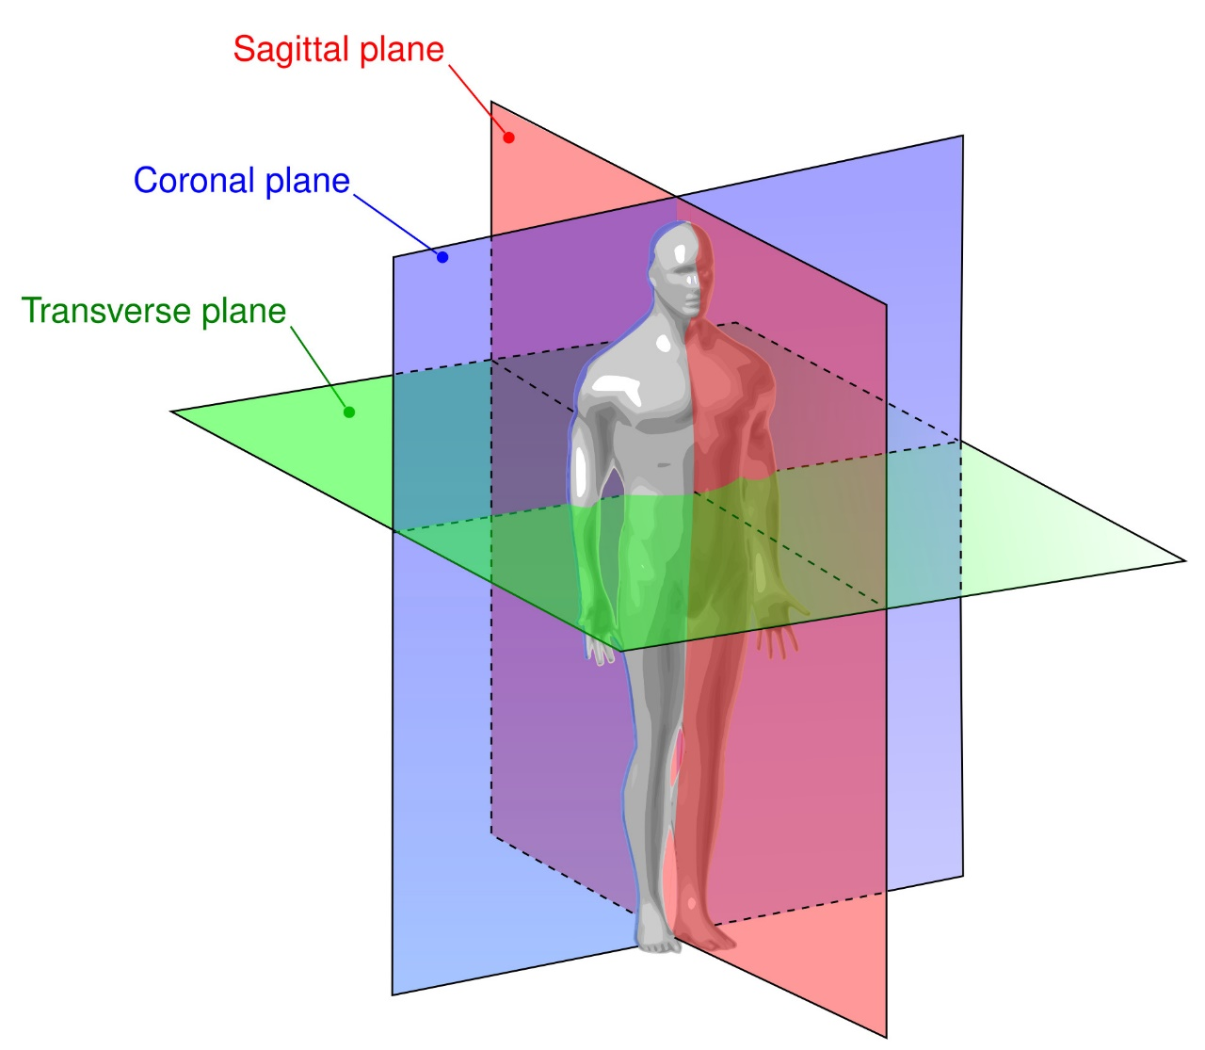

Image source: GYassineMrabetTalk, [CC BY 3.0](https://creativecommons.org/licenses/by/3.0), via Wikimedia Commons(8)

*FUN FACT!* The rapid changing of the gradient fields necessary for EPI (and other imaging sequences) cause audible vibrations in the MRI machine that sound like loud clicking sounds with various patterns, depending on the imaging sequence.

## Guided Inquiry Questions

1. On the MRI (A, B, C) and CT (D) images below, give the name of the specific plane that each image was taken from and suggest which region of the body is shown.

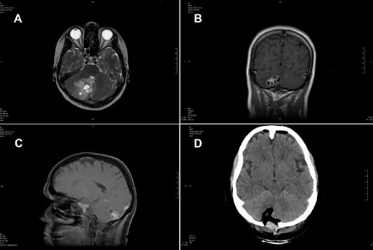

Image source: Vasileios Ntoukas, Dennis Tappe, Daniel Pfütze, Michaela Simon, and Thomas Holzmann, Public domain, via Wikimedia Commons (9)

# What Provides Contrast in MRI Images?

One of the many reasons MRI has become such a critical tool for medical diagnostics is due to the many different ways to provide contrast to the images, often by just changing the timing of the imaging sequence. This enables ways of highlighting specific tissues, or visualizing the differences between healthy and diseased tissue.

Below we will explore in depth the following three most common ways of influencing signal intensity in MR:

* proton (hydrogen) density (PD)
* weighting (using TR)
* weighting (using TE)
* contrast media

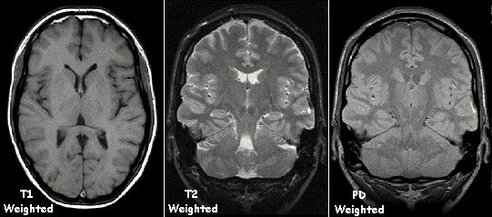

Image source: KieranMaher at English Wikibooks, Public domain, via Wikimedia Commons (10)

## Proton Density

This simplest imaging method is simply using a long enough TR so that the signal intensity in the image is primarily due to the density of nuclei in the sample. Since the vast majority of MRI is done looking at H nuclei (protons), this essentially provides the proton density in the sample.

However, there is one important caveat, despite solid bone having a high density of protons, there is often no signal from bone in any MRI images because the short and long times for solids compared with the soft-tissues and liquids in the body.

## and Weighting

Table courtesy of Allen D. Elster, MRIquestions.com (11)

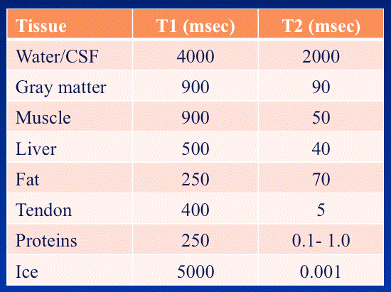An easy way to add contrast to MR images is to make use of the different relaxation times of the tissues within the sample (see the table in the margin). For example, using shorter TR times causes more obvious differences in the signal intensity for tissues with different times. The use of longer TE times can provide more obvious differences in teh signal intensity for tissues with different . The choice of TR and TE times to provide different contrast is shown in the figure below.

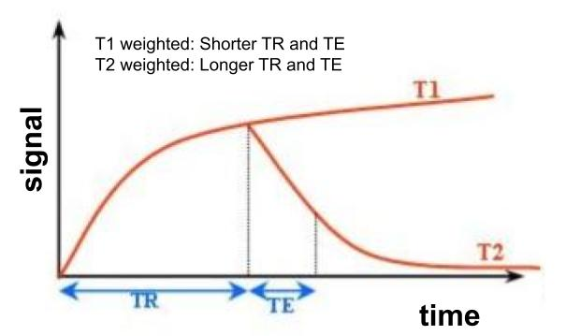

## Contrast Media

Along with these methods, scientists have developed ‘contrast media’ or ‘contrast agents’ that can attach to specific parts of the body. These contrast agents have non-toxic paramagnetic substances (often gadolinium) that generate small local magnetic fields that shorten the relaxation times of the surrounding magnetic nuclei.

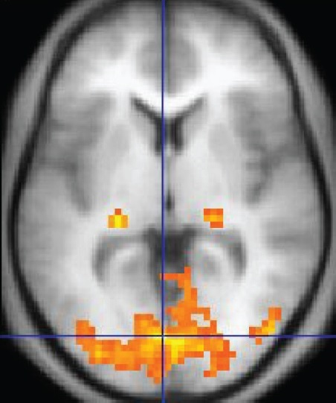The body naturally contains some paramagnetic substances, including the degradation products of hemoglobin and molecular oxygen. Taking advantage of these natural paramagnetic substances in the body (particularly the different magnetic properties of oxygenized and deoxygenized blood) is key to some MR imaging techniques like functional MRI.

(Upper Right) MR image with contrast media. Courtesy of Merideth Frey.

(Lower Right) Functional MR image. Changes in blood oxygenization levels are depicted in color overlaying an MR image. Image source: OpenStax, [CC BY 4.0](https://creativecommons.org/licenses/by/4.0), via Wikimedia Commons (12).

## Guided Inquiry Questions

1. The easiest way to decipher which type of imaging sequence was used in an MRI image of the brain is to look at the signal intensity of cerebrospinal fluid (CSF) in comparison with the gray matter of the brain.
2. The CSF looks much darker than the gray matter in the -weighted image. Why is that the case?
3. The CSF looks much brighter than the gray matter in the -weighted image. Why is that the case?
4. Look carefully at the fMRI image shown in the margin.
5. What plane was the image taken from?
6. What type of imaging sequence (PD, weighting, weighting) do you think was used for the background?
7. Why might different blood oxygenation levels provide contrast in MRI images?
8. What are possible advantages of adding contrast media, compared to the other image contrast mechanisms discussed?

# Reflection Questions

1. In the history of MRI given in the text, what were various challenges that Lauterbur and Mansfield had to overcome in order to get MRI to be widely accepted?
2. MRI is almost predominantly looking at H in blood, soft-tissues, and other bodily fluids. Provide possible MR and biological reasons for using H instead of another nuclear isotope.
3. The images in question 16 are of the brain of a 51-year-old woman infected with tapeworm larvae. The MRI images were taken using weighting (A), weighting (B), using a contrast agent (C), and then the final image (D) was made using a CT scan post-operation after the larvae were removed. Why do you think these doctors used these different imaging modalities for diagnosis and post-operation imaging?
4. Using what you understand about MR and have learned about MRI in this module, what are some potential limitations and challenges for MRI?

# Supplemental Readings

**State of the Art in Magnetic Resonance Imaging:**

<https://pubs.aip.org/physicstoday/article/73/2/34/914484/State-of-the-art-in-magnetic-resonance-imagingAs-a>

## Cited Sources

1. <https://en.wikipedia.org/wiki/Functional_magnetic_resonance_imaging> “Wikipedia: Functional Magnetic Resonance Imaging”
2. <https://cinet.jp/english/advisor-of-cinet-ogawa/> “Seiji Ogawa, CiNet Advisor”
3. [https://commons.wikimedia.org/wiki/File:Paul_Lauterbur_2003_cropped.jpg](https://commons.wikimedia.org/wiki/File:Paul_Lauterbur_2003_cropped.jpg%20%20)  “Paul Lauterbur 2003 Cropped”
4. <https://doi.org/10.1038/242190a0> “LAUTERBUR, P. Image Formation by Induced Local Interactions: Examples Employing Nuclear Magnetic Resonance. *Nature* **242**, 190–191 (1973). <https://doi.org/10.1038/242190a0>”
5. <https://web.phys.ksu.edu/mmmm/> “Modern Miracle Medical Machines”
6. <https://commons.wikimedia.org/wiki/File:Peter_Mansfield_Leipzig.jpg> “Peter Mansfield Leipzig”
7. <https://physicstoday.scitation.org/doi/10.1063/PT.3.3797> “Peter Mansfield”
8. [https://commons.wikimedia.org/wiki/File:Human_anatomy_planes.svg](https://commons.wikimedia.org/wiki/File:Human_anatomy_planes.svg%20) "Wikimedia Commons: Anatomical Planes Figure"
9. [https://commons.wikimedia.org/wiki/File:Cerebral_MRI_of_Taenia_Crassiceps_tapeworm_infection.jpg](https://commons.wikimedia.org/wiki/File:Cerebral_MRI_of_Taenia_Crassiceps_tapeworm_infection.jpg%20) "Cerebral MRI of Taenia Crassiceps Tapeworm Infection"
10. <https://commons.wikimedia.org/wiki/File:T1t2PD.jpg> “T1 T2 PD Weighted MRI Images”
11. <https://mri-q.com/why-is-t1--t2.html> “Size of T1 versus T2”
12. <https://commons.wikimedia.org/wiki/File:1206_FMRI.jpg> “Wikimedia Commons: fMRI”